BATCH ID: B5-5M1E

ROLL NO: CITC1904067

NAME: ANUJA V

CODE:

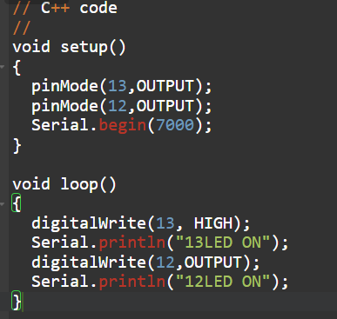

SIMULATION:

